Bash Prompt Customization.

Custom Bash Prompt

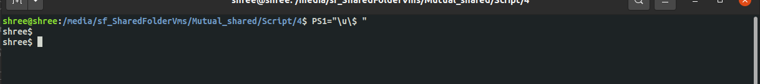

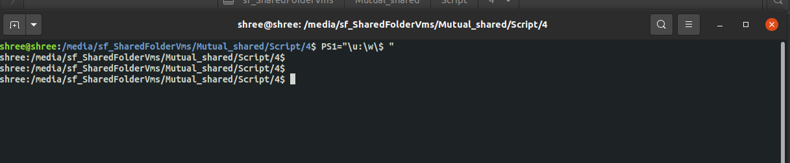

Adding Date to Bash prompt

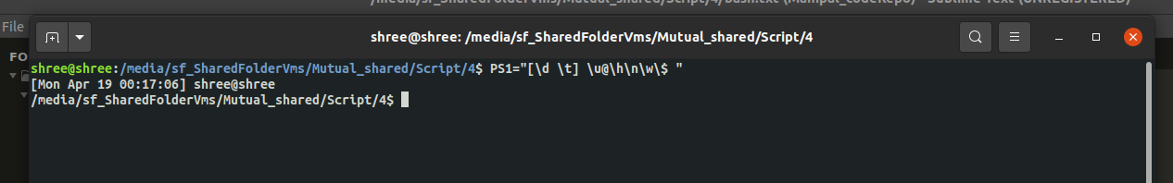

Changing the colour of Bash prompt

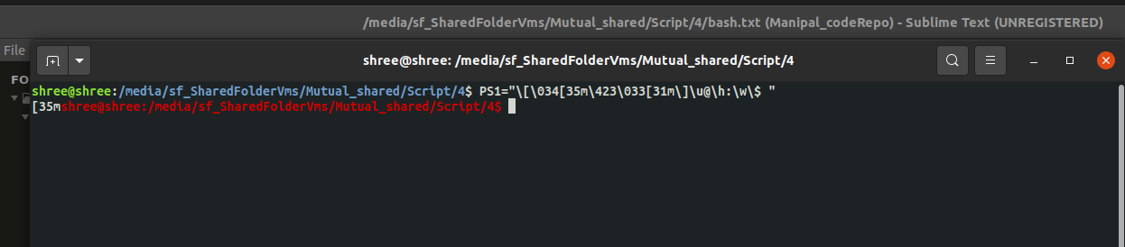

Perl Basics

#! /usr/bin/perl

print "hello world \n";

$name = "Shree";

($age,$contact) = (24,"1234567890");

$info = "$name contact number is \" $contact \" \n";

$info = qq{$name contact number is "$contact"\n"};

print $info;

($a,$b) = (5,6);

($b,$a)=($a,$b);

print "$a,$b\n";

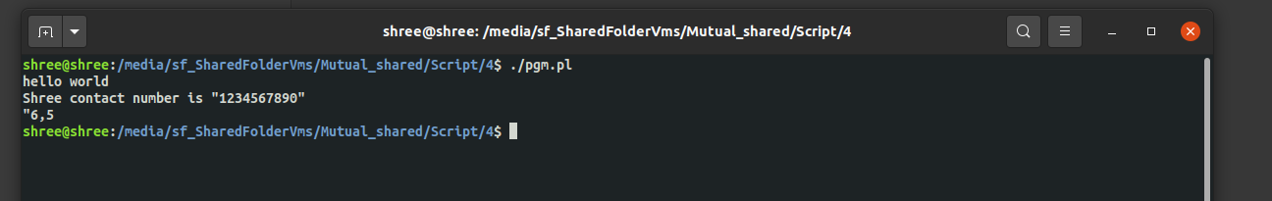

Arrays

#! /usr/bin/perl

@primes = (2,3,5,7,11,13);

@infoArr = ("manipal","msois","mit","kmc",10,20);

$infoArr[6] = "place";

print join(',',@infoArr),"\n";

for $var (@infoArr) {

print $var,"\n";

}

foreach $var (@primes) {

print $var,"\n";

}

for (@infoArr){

print $_,"\n";

}

